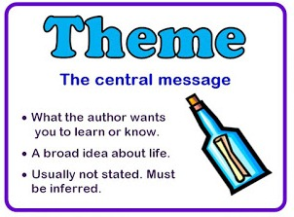

Topic(s)
•____________________ •_________________

•____________________ •_________________

1. The author believes ___________________________________________________

___________________________________________________________________.

2. The author believes __________________________________________________

___________________________________________________________________.

3. The author believes __________________________________________________

___________________________________________________________________.

4. The author believes __________________________________________________

___________________________________________________________________.

2025

In the Year 2025, I will be __________ years old.

I will be learning how to become a _____________________________.

How My Future Career Makes the World a Better Place

_____________________________________________________________________________________________________________________________________________________________________________________________________________________________________________________________________________________________________________________________________________________________________________________________________________________________________________________________________________________
___________________________________________________________________

“If you knew for sure what you were going to be when you grew up…you could get on with learning how to be whatever it is you want to be.” ~Shopkeeper (The Do-Nothing Frog)

Career Research Projects will begin after Thanksgiving Break!!!

