BOOK FAIR! BOOK FAIR! BOOK FAIR!
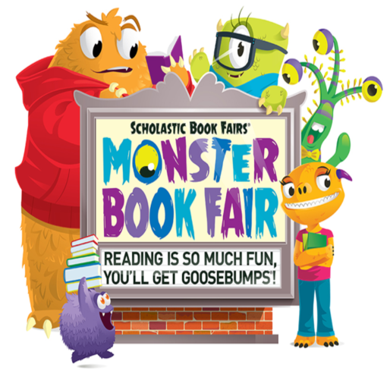

Tuesday, October 20, 2015

Dear Parents and Families:

Reading for pleasure inside and outside of school has real and long-lasting benefits. It unlocks the power of information and imagination and helps children discover who they are. Here’s what you can do to help children develop stronger reading skills and a love for reading:

- Set the example. Let children see you read.
- Have a collection of books in the home. Update this collection routinely to keep pace with changing tastes and reading skills.
- Support our school’s Book Fair. Allow your children to choose their own books to read.

Our Scholastic Book Fair is a reading event that brings to school the books kids want to read. It’s a wonderful selection of engaging and affordable books for every reading level. Please make plans to visit our Book Fair and be involved in shaping your child’s reading habits.

Book Fair Dates: Monday, October 26, 2015 through Friday, October 30, 2015
Location: TBD
Shopping Hours: Monday-Thursday: 8:30AM – 2:30PM
Friday: 8:30AM – 11:30AM

Students will automatically visit the Book Fair on their library support day. So that students are not limited to that one day to shop, students with money will have an opportunity to visit the Book Fair on the other days during support time. Though it is not required, you may use the enclosed Book Fair Cash Envelope to safeguard your child’s money and to ensure that money is solely spent on Book Fair purchases.

Review the Book Fair catalog for book pricing; prices listed in the catalog do not include tax. Book Fair purchases are taxed. Cash and credit cards accepted.

We look forward to your support during Book Fair Week! Remember, all purchases benefit our school.

If you have any questions, please contact our librarian at (901) 416-8080.

Sincerely,
Audrey M. Johnson, Principal

