Fairley Library Website Scavenger Hunt
fairleylibrary.weebly.com
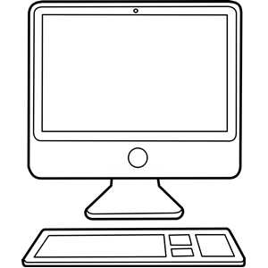
- What is one GOAL of the Fairley library? Write one goal.
- According to the rules (or POLICIES), what does the website say about lost books?
- According to the SERVICES page, how many cataloged resources does the Fairley library have?
- TumbleBook Library is a RESOURCE where children can read books online. What organization makes the resource available to the children of Memphis for free?
- What classes come to the library on Wednesdays?
- Fairley had two book fairs EVENTS last year. When did the book fairs occur? List the dates.
- When did Ronald McDonald visit Fairley Elementary? List the date.
- Last school year, what 1st grade student won the Bookmark Design Contest (what is the student’s first name)?
- Who are the Friends of the Library whose last name begins with a B?
- If parents need to contact the librarian, what is the phone number and email address where Ms. Smith can be reached?

Fairley Library Website Scavenger Hunt
fairleylibrary.weebly.com
- What is one GOAL of the Fairley library? Write one goal.
- According to the rules (or POLICIES), what does the website say about lost books?
- According to the SERVICES page, how many cataloged resources does the Fairley library have?
- TumbleBook Library is a RESOURCE where children can read books online. What organization makes the resource available to the children of Memphis for free?
- What classes come to the library on Wednesdays?
- Fairley had two book fairs EVENTS last year. When did the book fairs occur? List the dates.
- When did Ronald McDonald visit Fairley Elementary? List the date.
- Last school year, what 1st grade student won the Bookmark Design Contest (what is the student’s first name)?
- Who are the Friends of the Library whose last name begins with a B?
- If parents need to contact the librarian, what is the phone number and email address where Ms. Smith can be reached?

